**DBMS LAB – 5**

**Dept table:**

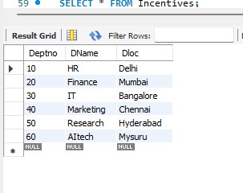

**Employee table:**

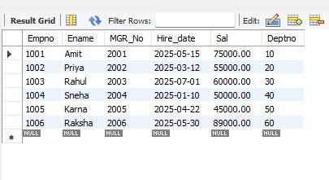

**Incentives table:**

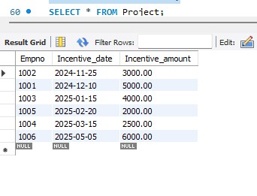

**Project table:**

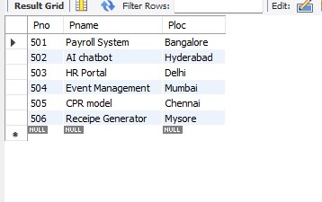

**Query 1:**

**Get Employee ID’s of those employees who didn’t receive incentives**

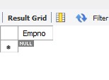

**Query 2:**

**Retrieve the employee numbers of all employees who work on projects located in Bengaluru, Hyderabad, or Mysuru**

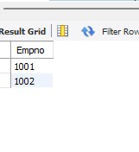

**Query 3:**

**v. Write a SQL query to find the employees name, number, dept, job_role, department location and project location who are working for a project location same as his/her department location**

